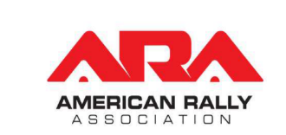
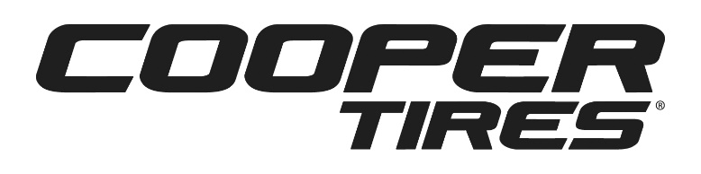

2020 Contingency Program Details

Program Summary Cooper Tires is a Contingency Sponsor of the American Rally Association and it is an optional contingency awards program.

Program Eligibility The Cooper Tire Contingency Program will be available to all ARA competitors who register in advance of any 2020 ARA National Rally Championship or Super Regional Events of the year and run Cooper M+S Rally Tires on their rally cars.

Eligible Classes Competitors entered in the following American Rally Association (ARA) classes (subject to change) are eligible to participate in the 2020 Cooper Tires Contingency Program:

- Open 4WD ARA National & Super Regional
- Naturally aspirated 4WD National & Super Regional
- Limited 4WD ARA National & Super Regional
- Open 2WD ARA National & Super Regional
- Limited 2WD ARA National & Super Regional

Important Note: National and Super Regional classes must have a minimum of four (4) entries take the start or compete, per race, per class, to qualify for participation in the 2020 Cooper Tire Contingency Program. If an ARA National Rally Championship event weekend also hosts multiple Regional Rally events, the overall results from each eligible class run that weekend will be combined to determine placement for Cooper Tire Contingency Program prizes.

Program Requirements In order to participate in the 2020 Cooper Tire Contingency Program, a team must have:
- Cooper M+S Rally Tires on ALL FOUR corners of their rally car
  - A pre-approved Cooper Tire may be substituted
- Proof of Purchase from an authorized dealer: A valid receipt
- Correct Logo Placement:
  - 4 decals - 1 on each corner of the car
  - Minimum decal size is 12” in length
- No competitor tire decals on the car or driver suit, and subject to strict enforcement
- Decals:
  - Can be requested from the Cooper Tire program manager, as needed.
  - Cooper can also provide artwork files to teams that make their own decals, however decals must be made to spec in terms of size, color and location

Program Registration Competitors who would like to participate in the 2020 Cooper Tire Contingency Program at ARA National and Super Regional Rally events must meet the requirements outlined above and must register prior to the start of an ARA National and Super Regional Rally event to be eligible for contingency awards provided by Cooper Tires.

To register, please send all required information and photos, in an email to the rally program manager:
Meg Snyder at: mrsnyder@coopertire.com

Award Information Cooper Tires will be awarding prizes based on finishing results in each eligible class, as well as a Social Media Award:
- 1st in Class – 4 Cooper M+S Rally Tires
- 2nd in Class – 3 Cooper M+S Rally Tires
- 3rd in Class – 2 Cooper M+S Rally Tire
  - A team may request a Cooper passenger or light truck product instead of a Rally Tire as an award replacement; subject to approval of rally program manager
  - All awards must be claimed within a 30 day period after the Event

Cooper Cruisers This is a loyalty program only for teams that compete in the 2020 ARA National and Super Regional events. Any registered Cooper Contingency Team that competes on Cooper M+S Rally Tires in six (6) or more ARA National and Super Regional events during the 2020 season, will receive four (4) Cooper M+S Rally Tires, compliments of Cooper Tire, to start their 2021 ARA Rally season.

Social Media Program The social media program is for 2020 ARA National Rally and Super Regional Rally events.

Important Note: For an event to qualify as a Social Media awarded event, a minimum of four (4) separate team entries must be registered prior to the start of the event, and a minimum of four (4) teams must complete the required posts for the event to qualify as an awarded event.

A driver or team must:
- Make a minimum of five (5) social media posts during a National or Super Regional rally event weekend, from their official public racing handles or pages.
  - The hashtag, #TeamCooperTire and tagging the @TeamCooperTire and @ARA_Rally handles in each post are required for that post to receive credit.
  - The posts must be media-based (i.e. photo or video) to receive credit and must be related to the event or competition in some way.
  - The program is available across Twitter and Instagram
- One Winner will be chosen via a live Periscope drawing amongst those that have followed all of the guidelines.
  - The Winner will have their choice to receive either four (4) Cooper M+S Rally Tires, Passenger Tires or Light Truck Tires or Light Truck Tires.

Registration - Submit an email with your official, public, social media handles to info@teamcoopertire.com.
Complete details and eligible posting dates will be emailed to each competitor prior to each race weekend, upon registration for the program.

2019 ARA One-Day Regional Events Cooper Tires will offer a separate contingency award for teams/drivers that compete in 2020 ARA One-Day Regional Events as listed on the ARA 2020 Schedule: https://www.americanrallyassociation.org/schedule

This contingency will follow the same guidelines as listed above in the Program Requirements and Program Registration sections. This contingency program will award the top three (3) highest finishing drivers, competing on Cooper Tires, which meet the conditions in the Program Requirements in a minimum of a thirty (30) car overall field.

Awards for the three (3) highest finishing teams/drivers, competing on Cooper Tires are as follows:
  - Highest overall – 4 Cooper M+S Rally Tires
  - 2nd Highest Overall – 2 Cooper M+S Rally Tires
  - 3rd Highest Overall – 1 Cooper M+S Rally Tire
    - A team may request a Cooper passenger or light truck product instead of a Rally Tire as an award replacement; subject to approval of rally program manager
    - All awards must be claimed within a 30 day period after the Event

Additional Information To Purchase Cooper Tires M+S Rally Tires:
Jess Von - Xtreme TM LLC
Email: jvon@xtremetm.net
Office: (541) 760 - 3966

To Contact the Cooper Tires 2019 ARA Contingency Program Manager:
Meg Snyder
Cooper Tire & Rubber Company
Email: mrsnyder@coopertire.com
Office: (419) 429-6758

To Contact the Cooper Tires 2019 ARA Contingency Social Media Program Manager:
Casey Ackerman
Marketing Activations Group
Email: info@teamcoopertire.com
Office: (614) 228-1484

